
Reflexions
Black Country Mental Health Support Team (MHST)
Information Booklet
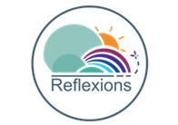
Contents

Who are Reflexions? 3
Our team 3
Our offer 3
Reflexions Offer 4
The Process 5

Who are Reflexions?
Reflexions are a NHS Mental Health Support Team (MHST) that are part of Black Country Healthcare Foundation Trust.
We work in schools to support children and young people experiencing mild to moderate mental health difficulties such as anxiety and low mood. We also work with the Senior Mental Health Lead (SMHL) in schools to support with raising awareness around mental health and emotional wellbeing throughout the school.
MHSTs aim to deliver 3 core functions:
- To deliver evidence-based interventions for mild-to-moderate mental health issues
- To support the senior mental health lead in each education setting to develop their whole school approach to mental health and wellbeing
- To give timely advice to school staff and liaise with external specialist service to help children and young people to get the right support at the right time.
Reflexions work in over 200 schools across the Black Country, covering primary, secondary and specialist schools in Walsall, Sandwell, Dudley and Wolverhampton.

Our Team

Reflexions mainly offer Cognitive Behavioural Therapy (CBT), alongside clinicians offering integrative approaches and a full administrative team.
Education Mental Health Practitioners (EMHPs)
EMHPs offer 1:1 and group support, targeted workshops and support schools with their whole school approach to mental health and wellbeing.
Children’s Wellbeing Practitioners (CWPs)
CWPs offer interventions and support to schools. CWPs are trained in working in the community and so their role will also include things like linking with local community groups.
Cognitive Behavioural Therapists (CBT)
Some of our practitioners are trained in high intensity CBT. They usually offer more sessions (10-12) to help with more long standing or complex difficulties that would still fall within the mild to moderate remit.
Senior Wellbeing Practitioners (SWPs)
SWPs have had additional training in supervision and some additional interventions.
Support Workers
Support Workers support with the whole school approach. You may see them supporting with things like assemblies, staff training and holiday activities.



Reflexions provide consultations and timely advice to Schools, other agencies and families. A consultation is an initial step to determine if a referral to Reflexions would be appropriate, which involves a meeting with the school's pastoral team and Reflexions. If Reflexions is not the most appropriate service to meet the needs of young people, we offer signposting recommendations.

Reflexions Offer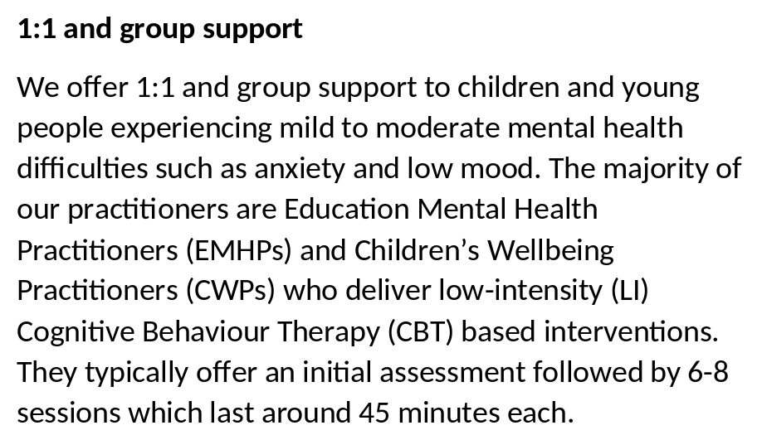c

1:1 and group support
We offer 1:1 and group support to children and young people experiencing mild to moderate mental health difficulties such as anxiety and low mood. We deliver low-intensity (LI) Cognitive Behaviour Therapy (CBT) based interventions. They typically offer an initial assessment followed by 6-8 sessions which last around 45 minutes each.



Targeted workshops
Reflexions deliver one-off workshops which are aimed at children and young people or parents/carers who may benefit from a bespoke offer exploring a particular area of need in more depth and detail. The aim is to provide knowledge, strategies and practical support. There are usually between 3 and 10 people in one workshop and they typically last for one hour.
You can find the targeted workshop referral form below


Whole School Approach (WSA)
We aim to work collaboratively with each education setting to complete a mapping tool to understand the current mental health and wellbeing support offer in the school including the strengths and areas for development. We have an offer open to all Reflexions education settings, with a focus on general awareness of wellbeing. The delivery of WSA will be discussed with the individual setting and this may be delivered in different ways including an assembly, whole class awareness raising, parent coffee morning and includes staff training.

Holiday Provision
Reflexions are a year round service, meaning we are open even during the school holidays. We offer a variety of workshops and events and link with local community groups such as the local football clubs and dance teachers.
Your Reflexions link practitioner should let you know about the upcoming holiday provision and share the flyers so you can share with students and parents.


You can find more information on our referral criteria and referral form here including who can refer and what to consider when making a referral:
Discharge
In their final session/s the young person will work with their practitioner to create a maintaining progress plan to think about what they have learned, what they have achieved and what they can continue to do to make progress. Once they have completed their sessions, they will be closed to the service. A discharge letter will be sent to summarise the work completed.

Sessions
If a child or young person is offered 1:1 or group sessions with Reflexions, they will typically be once a week for 6-8 sessions lasting 45 minutes each. They will usually take place in school but may take place in local community settings for example if they have sessions during the school holidays or are not currently attending school.
As part of our commitment to providing the highest quality care, we may request consent to video record therapeutic sessions. Many of our staff are attending University courses. Recordings help us in their ongoing assessment by viewing their work directly. In line with professional standards, any recordings are used solely for training, supervision, and professional development purposes, helping our team to continually reflect, learn, and improve. All recordings are stored securely, accessed only by authorised clinicians, and managed in accordance with UK General Data Protection Regulation (GDPR) and Data Protection act 2018.

Assessment
If the referral is accepted, we will offer an assessment. This will typically last for 1 hour and will be an opportunity to get to know the young person and what their current difficulty is. The assessment is all about finding out whether Reflexions is the right service to support the young person and if it is, what that support might look like. We will typically also speak to parents/ carers to get their view. If from the assessment we do not feel that Reflexions is right, we will advise on what may be more helpful instead.

Referral
A referral is needed for all 1:1 and group work. The SMHL needs to make or be aware of the referral. A Reflexions referral form will need to be completed and sent via email to the Single Point of Access. We will then triage the referral and either accept for an assessment or decline and sign-post to a more appropriate service.
The Process


